Gary Locke骆家辉 | 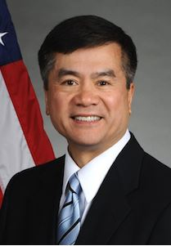 | Former Governor of Washington, US Secretary of Commerce and Ambassador to China  前华盛顿州长，美国商务部长暨驻华大使
Ambassador Gary Locke is a senior advisor and keynote speaker on behalf of USAChina Investments Group and its subsidiary companies.  On March 9, 2011, President Barack Obama nominated Gary Locke to be the 10th Ambassador of the United States of America to the People’s Republic of China. He was confirmed by the Senate on July 27, 2011 and was sworn in on August 1, 2011. He assumed duty as the Ambassador Extraordinary and Plenipotentiary to the People's Republic of China on August 13, 2011.  Previously, Ambassador Locke served as the Secretary of Commerce where he helped implement President Obama's ambitious agenda to turn around the economy and put people back to work. As the administration’s point person for achieving the President’s National Export Initiative, he presided over a 17 percent increase in exports from 2009 to 2010, while exports to China saw a 32 percent increase. Ambassador Locke also oversaw a significant first step in the president’s export control reform effort that strengthens national security, while making U.S. companies more competitive by easing their licensing burden for exports to partners and allies. | Before his appointment to the President’s Cabinet, Ambassador Locke served two terms as Governor of Washington, the nation’s most trade-dependent state. He expanded the sale of Washington products and services by leading 10 productive trade missions to Asia, Mexico and Europe. During the eight years of the Locke administration, Washington State gained 280,000 jobs despite two national recessions.  As both Governor and Commerce Secretary, Locke’s innovations in government efficiency, customer focus, and priority based budgeting, as well as successful and under-budget management of high risk initiatives, have won him acclaim by nationally recognized authors and organizations, including Harvard’s Kennedy School of Government.  Along with his longstanding commitment to public service, Ambassador Locke has extensive experience working with China. As Secretary of Commerce, he co-chaired two sessions of the U.S.-China Joint Commission on Commerce and Trade that resulted in important changes to Chinese trade policy, helping to level the playing field for U.S. businesses exporting to and operating in China. | As Governor of Washington, he successfully strengthened economic ties between China and Washington State, more than doubling more than doubling the state's exports to China to over $5 billion per year. As a partner in the Seattle office of the international law firm, Davis Wright Tremaine LLP, he co-chaired the firm's China practice.  Ambassador Locke is the first Chinese-American to serve as Ambassador to China, as Secretary of Commerce and as Governor. His grandfather emigrated from China to Washington State, initially finding employment as a servant, working in exchange for English lessons. His father, also born in China, was a small business owner, operating a grocery store where Ambassador Locke worked while receiving his education from Seattle's public school system.  Ambassador Locke earned a bachelor's degree in political science from Yale University and a law degree from Boston University. He is married to Mona Lee Locke and they have three children together: Emily, Dylan, and Madeline.
Jian Liu 刘健 | 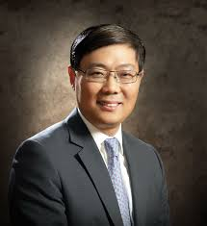 | China Consul General in L.A. Ambassador Liu Jian  中国驻洛杉矶总领事刘健大使
Edmund G. Brown Jr. (Invited) | 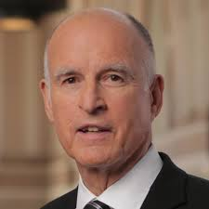 | California Governor  加州州长
Edmund G. Brown Jr., known as Jerry, was born in San Francisco on April 7, 1938. He attended both public and parochial schools, graduating from St. Ignatius High School in 1955. He completed freshman year at the University of Santa Clara before entering Sacred Heart Novitiate, a Jesuit seminary in August 1956. In 1960, he left the Society of Jesus and enrolled at the University of California at Berkeley. He received his B.A. degree in Classics the next year and then entered Yale Law School, where he graduated in 1964.  Following law school, Brown worked as a law clerk at the California Supreme Court, traveled and studied in Mexico and Latin America and then took up residence in Los Angeles, working for the prestigious law firm, Tuttle & Taylor. In 1969, Brown was elected to the Los Angeles Community College Board of Trustees, placing first in a field of 124. In 1970, he was elected California Secretary of State.  Brown was elected Governor in 1974 and reelected in 1978, by a margin of 21%. During Governor Brown's tenure, California created 1.9 million new jobs, almost double the national rate. | During his eight years in office, Brown marshaled both Democrats and Republicans in the legislature to slow the growth of state government, eliminate capital gains taxes for many small businesses, abolish the business inventory tax, index personal income taxes, adopt the nation's first energy efficiency standards, and make California the leader in co-generation, solar and wind energy.  As governor, Brown consistently had budgets approved on time and built a prudent budget surplus to serve as a "rainy day fund". He reduced the number of state employees per 1,000 Californians from 9.6 in 1975 to 9.2 in 1982. The tax burden for California residents declined from $6.90 per $100 of income in 1975 to $6.72 in 1982.  While curbing the growth of state government, Brown instituted cutting-edge environmental protections that became guidelines for the nation to follow. He strengthened the California Coastal Commission and established comprehensive policies governing development along the coast. He signed the nation's first legislation requiring high school students to demonstrate basic proficiency before graduation. State funding for higher education, including community colleges, more than doubled during Brown's eight years as governor. | In the field of crime fighting, Governor Brown enacted hundreds of tough anti-crime measures, including the "Use A Gun Go To Prison" Law and mandatory sentences for rape, sale of heroin, violent crimes against the elderly, child molestation and selling PCP. He established and funded the Career Criminal Prosecution Program, the Career Criminal Apprehension Program and the Crime Resistance Task Force.  As Mayor, Brown spearheaded the revitalization of a downtown that had been dormant for decades. He helped create new housing units for more than 10,000 people, re-opened the beautiful Fox Theatre (which had been shuttered for 30 years), and attracted many new restaurants, businesses and art galleries to the city. Brown also personally founded the renowned Oakland School for the Arts (housed in the Fox Theatre) and the Oakland Military Institute. Both schools serve students from the 6th grade through the 12th and are among the best performing schools in Oakland. During his 8 years as Mayor, the number of serious crimes was reduced by over 30% compared to the previous 8 year period.  Governor Brown is married to Anne Gust Brown, who serves as Special Counsel in the Office of the Governor.
Eric Garcetti  (Invited) | 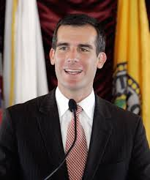 | Mayor of Los Angeles  洛杉矶市长
Eric Garcetti is the 42nd Mayor of Los Angeles. His "back to basics" agenda is focused on job creation and solving everyday problems for L.A. residents.  Garcetti was elected four times by his peers to serve as President of the Los Angeles City Council from 2006 to 2012. From 2001 until taking office as Mayor, he served as the Councilmember representing the 13th District | which includes Hollywood, Echo Park, Silver Lake, and Atwater Village -- all of which were dramatically revitalized under Garcetti's leadership.  Garcetti was raised in the San Fernando Valley and earned his B.A. and M.A. from Columbia University. He studied as a Rhodes Scholar at Oxford and the London School of Economics and taught at Occidental College and USC. | A fourth generation Angeleno, he and his wife, Amy Elaine Wakeland, have a young daughter. He is a Lieutenant in the U.S. Navy reserve and is an avid jazz pianist and photographer.
Richard Swanson | 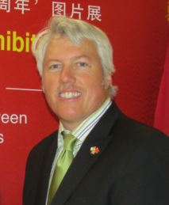 | Director  Pacific South Network  U.S. Commercial Service  U.S. Department of Commerce  美国商务部西南区主任
Richard Malcolm Swanson Jr. is the Director of Pacific South Network (Region) of the Office of Domestic Operations for the U.S. & Foreign Commercial Service (US&FCS). The US&FCS is the export promotion and FDI field arm of the International Trade Administration within the U.S. Department of Commerce. Richard oversees Nevada, California and Hawaii through the U.S. Export Assistance Centers, the field operations of his agency. | Mr. Swanson has worked with the US & FCS for over 24 years and started as an unpaid intern back in February of 1990. Mr. Swanson holds a Bachelor’s Degree from Cal State Fullerton in Int’l Business w/a minor in Spanish and a Masters of Public Administration in local economic development from Long Beach State. He has been an adjunct professor at Cal State University system for a number of years teaching international business.  Richard has been to many industry-related domestic and international trade events in the United States, Asia, Latin America, and Europe. | Mr. Swanson served as acting Senior Commercial Attache for the U.S. Embassy in Tel Aviv, Israel in 2001. Richard has been a global team leader for the ICT sector and the Europe, respectively. He has also served on the Aerospace and Education & Training teams as well. Richard received a Bronze Award in 2006 for his work on “Imagine Asia” with the entertainment industry and Hong Kong.  On a personal level, Richard is a native of California being born in San Diego and now living in Laguna Niguel, California with his wife and two daughters.
Brian Peck | 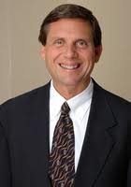 | Deputy Director, International Affairs and Business Development at the Governor’s Office of Business and Economic Development (GO-Biz)  加州州长办公室主任兼商务经济发展办公室国际事务与商务发展副主任
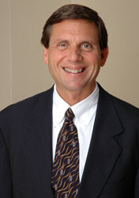  Brian Peck serves as deputy director in charge of international affairs and business development for the Governor’s Office of Business and Economic Development (GO-Biz). GO-Biz is the lead state entity for economic strategy and marketing of California on issues relating to business development, private sector investment, economic growth and international trade and investment.  Appointed in August 2013 by Governor Edmund G. Brown, Jr., Brian is responsible for promoting California as a destination for international investment as well as California exports of goods and services in the global marketplace. Brian’s office identifies opportunities to ensure California’s infrastructure and business climate are globally competitive.  Prior to joining GO-Biz, Brian was an international trade and intellectual property attorney, advising multi-national clients on international trade, regulatory and compliance matters, international government and policy affairs, global IP asset management and trade-related IP matters. He is an adjunct professor for international trade policy and also international intellectual property at USC Gould School of Law. | Brian served as Senior Director for Intellectual Property at the Office of the U.S. Trade Representative from 2003-2005, and Director of Japanese Affairs at USTR from 2001-2003. He was the lead negotiator for the intellectual property chapters in several Free Trade Agreements, including the U.S.-Colombia, U.S.-Peru and U.S.-Panama FTAs. He also oversaw the implementation of intellectual property provisions in the U.S.-Chile FTA and the CAFTA-DR Agreement. As Senior Director, Brian led an interagency team responsible for developing and implementing policies to strengthen the protection of intellectual property rights in Japan, Korea, Southeast Asia and Latin America; and was also responsible for overseeing U.S. trading partners’ compliance with bilateral and international obligations to protect and enforce IP rights. As Director for Japanese Affairs, Brian co-chaired the U.S.-Japan Information Technologies Working Group, and worked on regulatory reform initiatives in Japan’s legal regime for IP rights, as well as in the IT, e-commerce, and telecommunications sectors. He also led bilateral talks with several Asian countries under the WTO negotiations to liberalize international markets for services; and led the U.S. delegation at the WTO TRIPS Council meetings on IP matters. | Prior to his work for the U.S. Trade Representative, Brian was an attorney-advisor with the Office of the Chief Counsel for Import Administration at the Department of Commerce from 1998-2001, where he participated in a number of antidumping and countervailing duty cases. Brian also participated in litigation before the Court of International Trade and international dispute settlement panels, including an appearance before a WTO Panel in Geneva.  Brian graduated Order of the Coif and received his law degree, cum laude, from the University Of San Diego School of Law, where he served as a member of the San Diego Law Review. He received his B.A. from the University of California at Berkeley.
Dr. Zhihang Chi  池志航博士 | 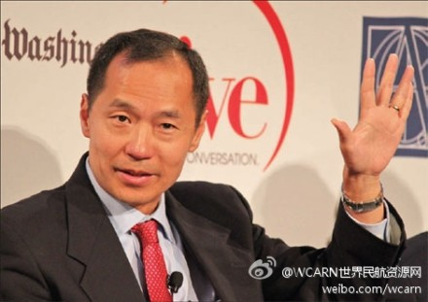 | Vice President and General Manager of Air China North America  中国国际航空公司副总裁暨北美区总经理
As the Vice President and General Manager of North America, Dr. Zhihang Chi manages all aspects of Air China’s business in North America from its headquarters in Los Angeles. In his role, Dr. Chi oversees 90- plus U.S. based Air China employees, the marketing and operations for the growing 36 flights between North America and China. Dr. Chi’s extensive experience in the airline industry, his visionary leadership and passion in promoting a closer and mutually beneficial Sino – U.S. relationship are credited for Air China’s significant growth in North America. Air China has nearly doubled its capacity in North America since he arrived at Air China.  Dr. Chi’s experience, training and educational background have prepared him well for the challenges of his position as the head of Air China in North America. | He worked in a number of increasingly responsible positions for Northwest Airlines from 1994 to 2003.  Dr. Chi’s experience, training and educational background have prepared him well for the challenges of his position as the head of Air China in North America. He worked in a number of increasingly responsible positions for Northwest Airlines from 1994 to 2003. During his years at Northwest, he developed and managed a number of strategic alliances with other international carriers, especially with the Chinese air carriers.  He joined Air China in 2004 and has led the company’s unprecedented growth in North America.  Before he was promoted to Vice President and General Manager for North America in April 2008, | Dr. Chi was General Manager, Western USA for two years until November 2006.  Prior to this, he was responsible for Air China’s Los Angeles office. Dr. Chi’s unrelenting advocacy for visa reform for Chinese visitors has made him a familiar figure to senior members of the U.S. Congress, State Department and the U.S. Homeland Security with whom he has personally met. Fluent in English and Chinese, Dr. Chi’s background makes him uniquely qualified to speak on China and U.S.-China relations. A naturalized U.S. citizen, Dr. Chi was born in China. He earned his doctorate and master’s degrees from the Sloan School of Management of the Massachusetts Institute of Technology (MIT) and received his bachelor’s degree and a master’s degree from Peking University in Beijing.
Ed Fuller | 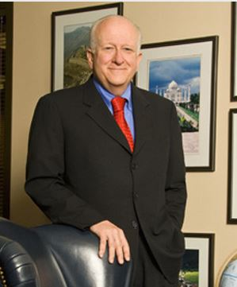 | President and CEO of the Orange County Visitors Association  and Former President & Managing Director of International Lodging, Marriott International  橙县企业旅游协会主席，前万豪国际集团国际部总裁兼总经理
President and Founding Partner of Laguna Strategic Advisors, an Irvine, California-based global consortium that provides opportunities and services to independent members of business consulting services. Also, current President and CEO of the Orange County Visitors Association, helping expand tourism to Orange County, California into the global industry.  Previously, I had a dynamic career with Marriott International that culminated with my being the company’s President & Managing Director of International Lodging for nearly 22 years. | My experience included roles such as chief sales and marketing officer, global leader in crisis management situations, future business assessment, top-level customer relationship management, sales and marketing leadership and long-term strategy development that applied corporate philosophies, delivered on brand promise and enabled ethical decisions. While working at Marriott International, my strategic leadership resulted in the creation of over $8 billion in annual sales, 80,000 jobs worldwide and the formation and operation of 555 hotels in more than 73 countries.  In March of 2011, Wiley published my first book,  "YOU CAN'T LEAD WITH YOUR FEET ON THE DESK! - BUILDING RELATIONSHIPS, BREAKING DOWN BARRIERS, AND DELIVERING PROFITS." | It was well received, ranking as a top 20 bestselling business book in its first month and is now available in both Japanese and Mandarin Chinese.  In addition to my corporate accomplishments I contribute passionately to multiple environmental, youth and educational initiatives. I am an active alumnus of Boston University, and am honored to work closely with this highly regarded educational institution.  I am also a regular contributor to www.forbes.com where my semi-monthly blogs focus on business trends in Asia, the global lodging industry and social commentary; and I contribute quarterly to www.globalhotelnetwork.com on hotel industry trends.
Charles Ding | 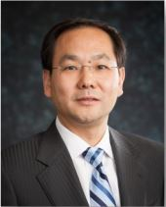 | Corporate Senior Vice President Chief Huawei Representative in the United States  华为集团资深副总裁
Mr. Ding has over 23 years of experience in the telecommunications industry. He joined Huawei in 1995 and over the last 17 years has held a range of senior executive positions with Huawei Technologies and its worldwide affiliates.  Mr. Ding came to the United States in August of 2010 as President of Huawei North America. | He currently serves as Corporate Senior Vice President of the Huawei global organization and the Chief Huawei Representative in the United States.  Prior to his current positions, Mr. Ding served as President of the Huawei Middle East and North Africa (MENA) region, before which he held the position of President of Huawei’s Global Sales Department. | Mr. Ding received his Bachelor’s Degree from the Beijing University of Posts and Telecommunications and his Master’s Degree from The Wuhai Research Institute of Posts and Telecommunications in China.  Mr. Ding is married and has two children. The family resides in Bethesda, Maryland.
Thomas M. Priselac | 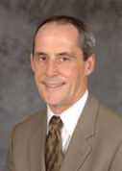 | President and CEO  Cedars-Sinai Health System  Los Angeles, California  美西最大私立医疗集团西达赛奈  Cedars-Sinai总裁兼首席执行官
Thomas M. Priselac is president and chief executive officer of the Cedars-Sinai Health System -- a position he has held since January 1994.  Priselac has been associated with Cedars-Sinai since 1979. Prior to being named president and CEO, he was executive vice president from 1988 to 1993. Before joining Cedars-Sinai, Priselac was on the executive staff of Montefiore Hospital in Pittsburgh.  Priselac has served the health care field in many ways in addition to his career at Cedars-Sinai. He currently serves as chairman of the American Hospital Association Board of Trustees. He is a past chair of the Association of American Medical Colleges, and he currently serves on the Los Angeles Chamber of Commerce Board, where he previously chaired the Health Care Committee. | He formerly chaired the Hospital Association of Southern California, the California Healthcare Association, and the Association of American Medical Colleges Council of Teaching Hospitals.  Priselac is an author and invited speaker on a variety of contemporary issues facing the health care field today including policy issues related to the delivery and financing of health care, health care quality and safety and the adoption and implementation of information technology. He is the holder of the Warschaw/Law endowed Chair in Healthcare Leadership at Cedars-Sinai Medical Center.  The Cedars-Sinai Health System is among the nation’s leading providers of health care services, medical education and research. Physician services are provided through the Cedars-Sinai Medical Care Foundation, a full-time academic faculty, and an active private attending staff. | Cedars-Sinai Medical Center, with revenues of over $1.7 billion, is the largest private hospital in the western United States and provides a full range of acute inpatient care services, rehabilitation medicine, and extensive outpatient diagnostic and treatment services. Cedars-Sinai Medical Center conducts National Institutes of Health and privately funded research, valued at approximately $65 million, on a broad range of research topics. The medical center also conducts graduate medical education in a broad range of specialties for over 310 residents and fellows.  A native of Pennsylvania, Priselac obtained a bachelor’s degree in biology from Washington and Jefferson College in Pennsylvania, and a master’s in public health, health services administration and planning, from the University of Pittsburgh.
Ifei Chang  张伊琲 | 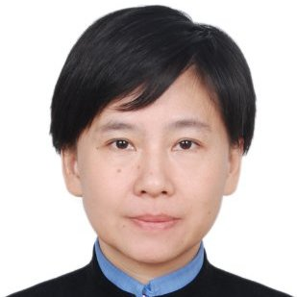 | CEO & President at Greenland US Holding Companies  上海绿地集团美国控股公司董事局主席兼总裁
Ifei Chang is a passionate leader and real estate executive with long track record of successfully leading billion dollars organization. Educated to a very high level, with extensive knowledge of real estate developments globally, ie Asia (China, Taiwan, Hong Kong, Japan), Russia, and USA.  She has verifiable success creating and delivering outstanding real estate investment strategies and development of large-scale, mixed use urban living projects in record breaking time, to name the latest US$1.4Billion Metropolis Mixed Use Project in Downtown Los Angeles and the US$4.6Billion Pacific Park Mixed Use Project in Brooklyn, New York. | She is fiercely intelligent and strong strategic acumen, is talented in identifying value acquisition targets, negotiate and engage various cooperation models with international business partners on multiple functional Real Estate Development, i.e. Co-Investment, Forward Deal, Joint Venture.  She is an inspiring and motivational leader, building multi-nationalities organization from ground up and ability to develop the vision for the company. Possessing vast managing skills and CEO experience, always ensure that clear objectives and expectations are delivered and maintained. | Ifei Chang graduated from Taiwan Chung Yuan Christian University and has a master degree from Yale University M.E.D, Architecture.
Stephen Cheung | 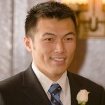 | President of World Trade Center - Los Angeles  洛杉矶世贸中心总裁
Stephen Cheung is the President of World Trade Center – Los Angeles (WTC-LA). The WTC-LA works to support the development of international trade and business opportunities for Southern California companies as the leading international trade association, trade service organization and trade resource in the Los Angeles region. WTC-LA promotes Los Angeles County as a destination for foreign investment to a targeted international audience to attract a significant flow of investment to the region, thereby enhancing the region’s economy, employment and business opportunities for local firms.  Prior to his current role, Cheung was the Secretary General for Los Angeles Mayor Eric Garcetti, and was responsible for managing policies and programs related to the Port of Los Angeles, Los Angeles World Airports, International Affairs and Global Trade. | Cheung serves on the Board of Director of the Los Angeles Regional Export Council and the Los Angeles Business Council, and was the lead organizer for Mayor Garcetti’s international trade missions to Mexico, China, Korea and Japan.  Concurrently, Cheung was the Director of International Trade for the Port of Los Angeles – the busiest container port in North America, and was responsible for developing programs to increase trade through the Port of Los Angeles and facilitate goods movement through the Southern California region.  Cheung joined the Port of Los Angeles and Mayor Garcetti’s Office after serving as Managing Director of International Trade and Clean Technology for former Mayor of Los Angeles, Antonio Villaraigosa. He was responsible for enhancing international trade opportunities for Los Angeles-based companies, and expanding the city’s role as a leader in international trade, entertainment, tourism, manufacturing and professional services. | Cheung was the City’s lead organizer for the historic visit to Los Angeles by Chinese President, Xi Jinping in 2012. Furthermore, Cheung implemented the city’s strategic plan to make Los Angeles a global capital of clean technology by building the infrastructure to support research, development and manufacturing with key partners such as the Los Angeles Cleantech Incubator and Port Tech LA.  A proud Angeleno, Cheung was born in Hong Kong and grew up in Los Angeles where he received both his Bachelor’s in Psychobiology and Master’s in Social Welfare from UCLA. He currently teaches a graduate-level course on public policy at the Luskin School of Public Affairs, and serves on the Advisory Council of USC’s Center for International Business Education and Research and the Los Angeles Cleantech Incubator.
Andy Cohen | 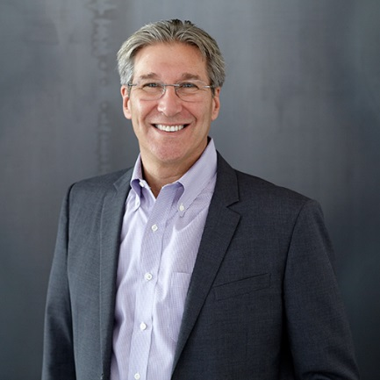 | CEO of Gensler  Gensler建筑设计公司总裁
Andy is one of three Co-CEOs of Gensler, whose collaborative leadership model sets itself apart in the marketplace as a leading global Design firm through its innovation strategies. Andy oversees Gensler’s global platform and its day-to-day operations, which span 4,500+ people, networked across 46 offices in 16 countries. | A champion of design, resiliency and sustainability, Andy is Chair of Gensler’s Board of Directors and leads the committee responsible for global design innovation initiatives, spearheading design excellence strategies across Gensler’s 27 diverse practice areas. As an engaged leader, Andy is also Regional Managing Principal for the Southwest U.S., with six offices in four states. Andy has been a speaker at many premier industry conferences, including the Urban Land Institute (ULI), Milken Institute Global Conference, Pension Real Estate Association (PREA), and TEDx. | Andy is also a Board Member of the UCLA Institute of the Environment and Sustainability and an active member of World President’s Organization (WPO). In his role as Co-CEO, Andy is one of the key contributors to what is acknowledged, by its peers, to be the most admired and largest architecture firm in the world, pioneering project types and design innovation strategies for the next century.
Sue Wong | 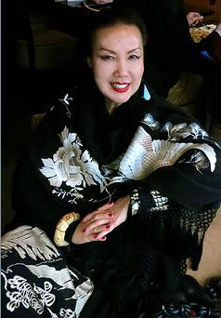 | Fashion Designer  时尚设计师
SUE WONG LIVES FOR ONE THING: TO SPREAD GLAMOUR AND BEAUTY!  SUE WONG is a study in contrasts. She appears petite, yet possesses a commanding presence and grand energy that fills an entire room. While there is power and strength in her designs, there is a romantic fantasy and poetic lyricism that informs her work, which nonetheless remain rooted in undeniable pragmatic reality. The elegant economy of her gestures belies the strength and determination with which she has managed her business for over two decades. This collision of polar opposites creates the frisson that fuels Sue Wong’s gorgeous designs and has established the Sue Wong signature style.  Born into humble circumstances in a remote countryside in southern China, at the age of six, Sue was spirited away from Communist China by the courageous leap of her mother, who bribed a border guard with her wedding jewels in exchange for freedom into Hong Kong with her young daughter. Journeying to the United States a year later, mother and child reunited with Sue’s father in Los Angeles. As a child, her initial creative tendencies drew her to art. The daughter of struggling immigrants, there would be no budget in the spare family economy for toys; Sue would create her own paper dolls and their entire lavish wardrobe, practicing her nascent interest in Fashion Design. However, Sue started making her own clothes when she was nine years old. | In High School she was chosen from over three hundred female classmates to be a member of the May Company Teen Board, and landed the opportunity to work in various capacities including modeling, assisting in window display and merchandising. While she was still trying to earn a fashion degree, she interned with the resource brand Arpeja, after winning first place in a scholarship sponsored by the company, apprenticing under the head designer.  Sue Wong left Arpeja to open up a one-of-a-kind boutique shop in Bohemian Venice, California, and later, another upscale boutique in West Hollywood with a stunning Art Deco interior. It was during this period that her signature vintage style was born and solidified. Sue took details from vintage garments from the Twenties, Thirties and Forties, extracted the hand-made detailing such as beadwork and embroidery and redesigned an entire new garment, incorporating the detailing of the vintage embellishments into her new design. These elaborate creations were displayed and hung from wires suspended from the ceiling to create a gallery effect in her boutiques. She attracted a glamorous audience and following including Bianca Jagger and Goldie Hawn who were drawn to the beauty, magic and uniqueness of her designs.  Ironically, after two design stints with smaller companies, Sue returned back to Arpeja to claim the position of chief designer for the label’s Young Edwardian. She became an immediate stellar success, bringing the company's sales from a mere 2 million dollars in revenues of over 52 million dollars within a three year period--a stunning, unprecedented success for the times. | Her attempt at launching her own line at age 30 was ill timed. She was in the midst of an acrimonious divorce and raising two young sons. Undeterred, she relaunched her brand five years later, rolling out an initial collection of Sue Wong day dresses to critical acclaim in 1985. Eventually, she introduced more elaborate evening pieces in 1999, a move that would firmly establish her signature style of haute glamour, femininity and romantic vintage sensibilities.  With each new collection, Sue Wong never fails to astonish, employing the revered age-old couture techniques implemented by the finest Couture houses in Europe, and evoking the allure and glamour of various eras such as Weimar Berlin, 1930s Shanghai, Precode Hollywood and Manhattan’s gilded Jazz Age. While often adopting vintage style, every design belongs in the now and is decidedly very Sue Wong; exquisite fabrics shimmering with incandescent beads, unique embroideries and layered textures embellished with passementerie and soutache combine to create works of art that are graceful, elegant, unique and timelessly beautiful.  Sue Wong truly captures and embodies through her work, her mantra of Beauty. Magic. Transformation. It is the Eternal Feminine Goddess energy that Sue Wong aspires to honor in every woman, creating beauty and sorcery that both enchants as it empowers, leaving a trail of wistful romantics speechless in its wake...
Jinhua Shen  沈锦华 | 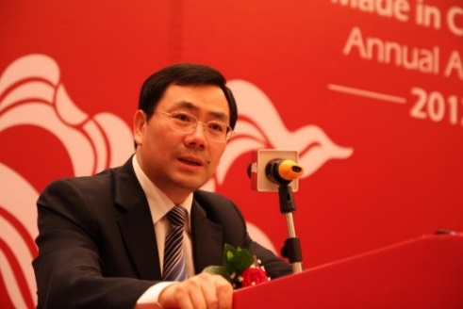 | President of Focus Technology Co., Ltd.  焦点科技股份有限公司创始人，现任公司董事长兼总经理
Jinhua Shen is the Chairman of Focus Technology Co., Ltd. which was established on January 9, 1996 and went public on December 9, 2009. He also owns the Made-in_China.com 中国制造网, which is the third largest B2B platforms.  Focus Technology Co., Ltd. also owns Xin YiZhan Insurance Agency Co., Ltd. or xyz.cn 保险网购新一站，an online insurance one-stop services; | Abiz.com 百卓 which offers professional procurement services to Chinese small to medium-sized enterprises; Focus Imp. & Exp. Services Co. Ltd., a global trade comprehensive service platform; and Leadong.com 领动云建站， which puts business management and e-commerce together.  Regarding he being called “Jack Ma Jr.” by some media, Jinhua Shen said: | “I don’t know whether I should laugh or cry over it: Jack Ma is only 3 years older than I am, it was one year after the Made-in-China.com was established, he had the idea to establish Alibaba.” As to the ranking of the third place in B2B platform, Jinhua Shen thinks the B2B market is huge and there is no need to rank or categorize the generations. He said that he liked Jack Ma and thought Jack Ma as the “speaker” of their business.
Larry Namer | 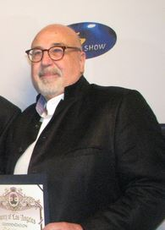 | President/CEO, Metan  Metan 娱乐公司总裁/首席执行官
Larry Namer is an entertainment and media entrepreneur who, along with Alan Mruvka, founded E! Entertainment Television and Movies USA Magazine.  Namer graduated from Brooklyn College in 1971 with a degree in Economics. After graduation, he worked as an assistant cable splicer for what was then called Sterling Manhattan Cable which was later acquired by Time Inc.  After several years as a technician, he became the Vice Chairman of the Cable TV division of the Electrical Workers Union. By age 25, he became the Director of Operations at Manhattan Cable and a year later was given sales and marketing. In 1979, he became Director of Corporate Development and was charged with building businesses derived from non-entertainment uses of the cable TV systems.  He became VP/General Manager of Valley Cable TV in Los Angeles and involved in the program department.  Namer and his friend Alan Mruvka created a plan for a TV network named Movietime, that would eventually become E! Entertainment Television. Namer and Mruvka eventually sold their stake in the company.  In 1989, he was awarded the President's Award from the National Cable Television Association. | While remaining on the Board of E!, he started a media company in Russia. The company promoted or produced several hundred rock concerts and brought the soap opera Santa Barbara to Russia.  Namer has played a significant part in launching several other TV networks around the world and interactive television, serving as a consultant to Microsoft. After E!, Namer created and launched several companies in the United States and overseas, including Steeplechase Media, Comspan Communications, Comspan Russia, and, with Martin Pompadur and Jean Zhang, Metan Development Group.  In September 2011, Namer was named as the first recipient of the “Aaron Spelling Award” at 4th Annual Investment Seminar & Global Independence in Beverly Hills. In October 2011, Namer joined the Advisory Board of SuperBox Inc.  Today, Namer is recognized as one of the world’s leading experts on new technology and how it is fundamentally altering the business of international media and entertainment. Among the companies that have enlisted his expertise are Microsoft, Paul Allen’s Digeo, World Digital Media Group (a joint venture of Radio Shack), EchoStar and Sirius Radio network. | Mr. Namer currently serves as President/CEO, Metan. Metan’s flagship series is Hello! Hollywood!, a weekly entertainment news series tailored to Chinese audiences, offering up the latest in celebrity, pop culture and lifestyle news. Since its launch in summer 2009, the series is now available on over 40 television stations in China and six in North America reaching over one billion Mandarin speaking viewers. Hello! Hollywood’s premier content is also available on 10 of China’s top online portals, reaching more than four million viewers weekly.  Metan is currently adapting popular Western TV formats for localized versions, including 'Go Dance!' from Ukraine and 'Elite Model Search.' The company has also developed the original sitcom 'Return to Da Foo Tsun' and the Web series Planet Homebuddies that has garnered an online audience of over seven million only one month since its launch. 'Return to Da Foo Tsun' has the distinction of being the first Chinese comedy to receive a nomination for the prestigious Television Asia Awards in 2013. Metan was instrumental in joining together top China production houses Mei Tian and H&R Century TV with Warner Brothers International Television Production and the creators of 'Gossip Girl' to develop a groundbreaking new teen drama series for China, to which Metan is also a consultant.
Wei Tongwei  魏同伟 | 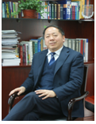 | General Secretary of Auto Repair Parts Committee, China Automotive Maintenance and Repair Trade Association  中国汽车维修行业协会  汽车维修配件工作委员会秘书长
Tongwei Wei started working in SOEs such as China Dongfeng Motor Corporation and China Automotive Group in 1970s, who after 1995 focused on domestic auto markets, especially the businesses relevant to after-markets, and served as President in American National Automotive Parts Association (NAPA), and other auto service businesses such as SUNGAD and CHNAPU, and co-founded the DeMyCar Online Technology and DeMyCar Investments. | Mr. Tongwei Wei was the first person asserting “chain management is the necessary route of auto parts‘ distribution”, which idea was accepted by the management of People’s Bank of China and resulted in the first auto finance institute in China. Mr. Tongwei Wei also worked with China Railway Engineering Corporation （CREC）to establish the first insurance company focusing on both auto and engineering insurance and devoted to the research as well as management of service chains in between auto services and insurances, which company has been ranked top ten in the industry. | Mr. Wei is also the first investor who applies the model of “Interactions between Two Websites” in his auto service chain group, he integrates auto parts, maintenance, and insurance on the same service platform, whose essays regarding auto parts chain, maintenance chain and auto finance are referenced in the market practices. His operation modes and researches contribute to the development of China’s auto aftermarket. Mr. Tongwei Wei is a widely recognized leader in China’s auto aftermarket industry.
Henry Cisneros | 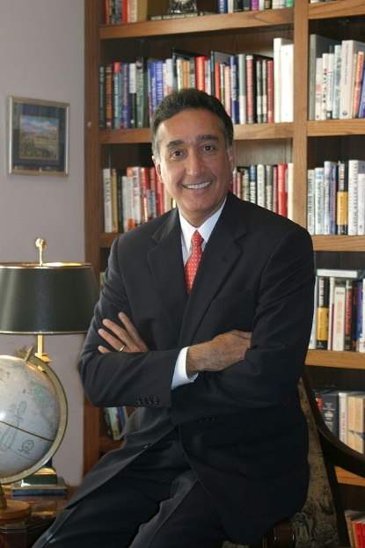 | Founder & Chairman, City View  City View地产投资管理公司创办人兼董事局主席
In 1981, Mr. Cisneros became the first Hispanic-American mayor of a major U.S. city, San Antonio, Texas. He was subsequently elected to four terms. In 1992, President Clinton appointed Mr. Cisneros to be Secretary of the U.S. Department of Housing and Urban Development ("HUD"). After leaving HUD in 1997, Mr. Cisneros became President and COO of Univision Communications, the Spanish-language broadcaster which has become the fifth-most-watched television network in the nation. | Mr. Cisneros currently serves on Univision's Board of Directors. He has served as President of the National League of Cities and as Deputy Chair of the Federal Reserve Bank of Dallas. He is currently a member of the Advisory Boards of the Bill and Melinda Gates Foundation and the Broad Foundation and was honored by the National Housing Conference as the "Housing Person of the Year". Mr. Cisneros sits on each of CityView's Investment Committees. | He is a graduate of Texas A&M with a Masters from the Kennedy School at Harvard and a Doctorate from George Washington University.
Lessing Gold | 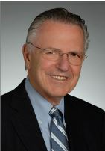 | Partner, Mitchell Silberberg & Knupp LLP & Co-Chair of World Trade Committee, World Trade Center Los Angeles, LAEDC  MSK法律事务所合伙人兼洛杉矶经济发展局世贸中心世贸委员会共同主席
contracts and  financings, the development of new technologies, licensing and regulatory issues, and  other emerging security and protective initiatives, as well as regulatory, antitrust and  liability issues. | Counsels clients regarding shareholder disputes, mergers and acquisitions, and contractual disputes. Represented security alarm companies in the United States and abroad (buyers and sellers) in nearly every major merger and acquisition transaction in the past decade.  Industry Focus  Represents many Asian companies coming to the United States. Frequent lecturer on  foreign direct investments, EB-5 transactions and doing business in the United States. Has encouraged many Asian companies to commence business operations in Los Angeles.  Professional Recognition  - Recipient of the George R. Lippert Memorial Award from the Security Industry  - Association for exemplary service to the security industry.  - Inducted into the SSI Hall of Fame for distinguished industry service to the electronic security industry.  - Recipient of Lifetime Achievement Award from the California Alarm  Association for service to the security industry. | - Honorary Vice President, Security Industry Association  AV® Preeminent™ Rating, Martindale-Hubbell  Publications and Presentations  - Frequent speaker at International Security Conference, Security Industry Association, and other industry association conferences on mergers and  acquisitions and legal liabilities.  - Contributing Legal Columnist, “Security & the Law,” SDM magazine.  - Frequent speaker in China on “Doing Business in the U.S.”  Professional, Business, and Civic Affiliations  - Co-Chair, World Trade Committee of the Los Angeles County Economic  Development Corporation (LAEDC)  - Board Member, Security Industry Association General Counsel, California Alarm
Sean Luo Xiangyang  罗向阳 | 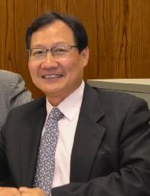 | President of China Mobile International (USA) Inc.  中国移动美国公司总裁
Mr. Luo is the President of China Mobile International (USA) and has been working in telecommunication industry for over 20 years.  Prior to joining China Mobile, Mr. Luo was the one of the founders for a startup company and led his team to reach more than US$10 million in annual revenue within 5 years. | Before that, He worked for CM Tel (USA) as the General Manager in Los Angeles and made this subsidiary of China Motion Telecom, a listed company in Hong Kong, be one of key players in the US IDD wholesale market. Later he was promoted as EVP to supervise all operations in both North America and Europe on behalf of China Motion Telecom. In 2005 he was also appointed as COO for China Motion Holdings in China. | Before he came to the States, he had worked for China Telecom Guangdong branch, serving as engineer, section chief and director respectively, for nearly 10 years.  Mr. Luo received his MS degree in Electronic and Communications System from South China University of Technology and his MS degree in Management and Policy from State University of New York at Stony Brook。
David Grant | 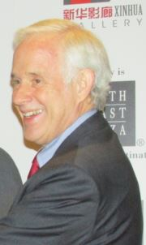 | General Manager of South Coast Plaza  南海岸购物商场股东及总经理
David has served as the General Manager of the South Coast Plaza for 36 years since 1979.  South Coast Plaza was built by the Segerstrom family.  C J Segerstrom & Sons is a family business incorporated as a major real estate company in Orange County, especially in the Costa Mesa, California, USA. Swedish immigrant Carl Segerstrom started out by buying a large lima bean farm in 1900. In 1967 construction began on the jewel in their crown, South Coast Plaza. | South Coast Plaza is an upscale-luxury shopping center, which is the largest mall on the West Coast, its sales of over $2 billion annually are the highest in the United States.  Segerstrom family's monetary donations provided for the construction of the Orange County Performing Arts Center, on land also donated by the family/company. Besides the performing arts center the family/company gives heavily to the local Newport-Mesa school district. | The family also owns land rights to much of the expanding commercial office space around the mall. Though they have sold the property rights to the residential areas south of the 405 Freeway, they still hold the mineral rights.  Grant has a BA degree of Business Administration from Chapman University.  David Grant, married to Andrea Segerstrom who is the daughter of Henry T. Segerstrom and grand-daughter of Carl Segerstrom, is a family member of the South Coast Plaza’s owner’s family.
Michael Gordon  高腾 | 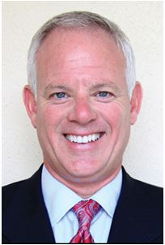 | Chairman and CEO of USAChina Investments Group  美中投资集团董事局主席暨首席执行官
Michael is currently the Chairman & CEO of USAChina Investments Group ("USCI") and its subsidiaries USCI Investment Management (Shanghai) Ltd., USCI Global Trade & Investment Center, USCI Real Estate Services Inc. and USCI Estate Management Services LLC. USCI is a global merchant bank and investment management company that specializes in private equity, cross-border foreign direct investment and global trade. In support of US-Sino relations, | Michael currently serves as a Global Corporate Sponsor and a former Advisory Board member of the Zhou Enlai Peace Institute in Beijing China, which fosters international trade relations between the US and China with government support from both countries. Michael is also an active member of the American-Chinese CEO Society and the ChinaUS Business Association. Since 2000 Michael has also owned and operated G Studios Marketing and Trading, a lifestyle brand development company and transnational trade & finance company working through the Otto Group, a $12B a year company and global leader in trade and trade finance. | During his career Michael has developed executive leadership expertise in the areas of Trans-global Strategic Partnering & Relationship Building; Cross Functional Team Building and Leadership; Merchant Banking & trade; and US/China business development. Over the past three decades, Michael has served on numerous corporate boards and actively participated in various trade and philanthropic organizations in a variety of leadership roles. Michael lives in the greater Los Angeles area with his amazing wife Beth and their beautiful daughter Mia Bella.
Michael Mohammed | 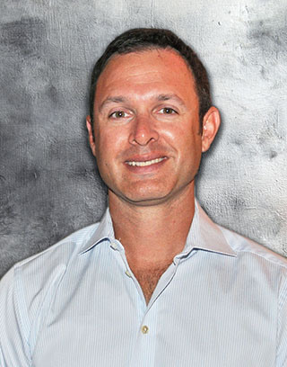 | CEO at Chronic Tacos Enterprises, Inc.  Chronic 塔可餐厅公司总裁
Michael Mohammed is the CEO of Chronic Tacos Enterprises, bringing with him 15 years of professional experience with an extensive background in finance and management. Upon completing his MBA, he began his career as a financial analyst for Boeing in Seattle Washington. | He eventually moved back to Vancouver BC to lead the sales division of Cattermole Timber, an integrated forest products company, eventually becoming President. After orchestrating the sale of Cattermole Timber Mr. Mohammed became involved in various projects in both real estate and private equity. | When he and his brothers helped finance the expansion of Chronic Tacos into Canada in 2010, Mr. Mohammed experienced the company’s unique culture firsthand and instantly recognized its great potential. The brothers decided purchase a controlling stake in Chronic Tacos where they have since built a strong culture and brand that is now positioned for exceptional growth.

